**ABSTRACT**

The agriculture sector is facing the major challenges because of the absence of direct supply chain between farmers and buyers. This will lead to vulnerabilities, reduce the farmers income and compromises product quality. To address these issues, we are developing a web portal which facilitates the visibility of farmers profiles making their details accessible to the wide range of buyers. This approach lets buyers to connect with farmers through the portal, allowing them to negotiate and quickly update price agreements.

To enhance transparency and security, our system incorporates Blockchain technology to record and securely store all transactions. Our innovative web portal strives to bridge the gap between farmers and buyers promoting transparency and trust in agriculture transactions. This approach has the potential to benefit both farmers and consumers while promoting sustainable practices within the agricultural sector.

Food safety and corruption hazards have generated an enormous need of an effective traceability results icing to enough product’s safety within the husbandry force chain. Block chain is the revolutionary technological system, which provides the groundbreaking result for commodity traceableness in husbandry and in food force chains.

**Keywords:**

Agriculture supply chain, Direct marketing, Blockchain, Traceability.

**CHAPTER 1**

**INTRODUCTION**

In today's world, the agriculture supply chain faces numerous challenges, including transparency, traceability, and direct marketing. Farmers struggle to find reliable buyers for their crops, and buyers face challenges in sourcing quality products at fair prices. The farmers get less price than the minimum selling price in the market because of many intermediaries present in the current supply chain. There is no clear and reliable record about the crop, origin, quality, and the final price. There is no direct communication and negotiation between the farmer and the buyer. Lack of transparency in transactions makes it difficult for the farmer and the buyer to trust each other leading to disputes.

To address these issues, our project focus on the development of a decentralized traceability and direct marketing system for agriculture supply chains. This innovative system empowers buyers, sellers, and administrators, fostering a more efficient and transparent marketplace. Buyers can seamlessly register, log in, and access detailed information about sellers' crops, enabling them to make informed decisions. They can also send requests to sellers, view responses, make payments securely, and log out, ensuring a user-friendly experience. Sellers, on the other hand, can register and log in to provide comprehensive crop information, view buyer requests, and track payments effortlessly. This system streamlines the marketing process for sellers, improving their reach and efficiency. Administrators have the capability to log in, manage fixed payments, and maintain the system's integrity. Our decentralized traceability and direct marketing system promise to revolutionize agriculture supply chains, enhancing transparency, trust, and efficiency across the industry.

* 1. **Problem Statement**

The problem at hand revolves around the need for a comprehensive and decentralized traceability and direct marketing solution within agriculture supply chains. Currently, there is a lack of transparency and efficiency in connecting buyers and sellers in this industry. Buyers struggle to access reliable information on available crops, while sellers find it challenging to manage buyer requests and payments. This inefficiency leads to missed opportunities and potential fraud risks. The proposed system aims to address these issues by enabling buyers to register, login, view seller crop listings, send requests, make payments, and logout seamlessly. Sellers can register, login, provide crop information, view buyer requests and payments, and logout. Additionally, an admin interface allows for fixed payment processing. This innovative solution will streamline agricultural supply chains, foster trust, and promote fair and efficient trade.

* 1. **Objectives**

To accomplish the project's purpose, the following particular objectives have been established.

1. To help farmers to sell their products in a direct and transparent manner by eliminating intermediaries.
2. To bridge the gap between farmers and buyers, promoting transparency, traceability, and trust in agricultural transactions by providing a digital platform for them to connect which helps farmers to get better pricing for their crops.
   1. **Scope of the Project**

The scope of this decentralized agriculture supply chain traceability and direct marketing system encompasses the development of a user-friendly platform for buyers, sellers, and an admin. Buyers can register, login, browse seller's crop listings, send purchase requests, view seller responses, make payments, and logout. Sellers can register, login, list their crops with detailed information, view buyer requests, and track payments before logging out. The admin's role is to manage crop prices. The system aims to streamline the agricultural supply chain, foster transparency, and facilitate efficient direct marketing interactions between buyers and sellers.

**CHAPTER – 2**

**LITERATURE SURVEY**

**[1] M. M. Aung and Y. S. Chang, ‘‘Traceability in a food supply chain: Safety and quality perspectives,’’ Food Control, vol. 39, pp. 172–184, May 2014.**

The paper by M. M. Aung and Y. S. Chang, titled 'Traceability in a Food Supply Chain: Safety and Quality Perspectives' (2014), introduces the pivotal concept of traceability within the context of food supply chains. It acknowledges the growing importance of traceability in ensuring food safety and quality, especially in light of foodborne illness outbreaks and increasing consumer concerns. The introduction highlights the need for effective traceability systems to enhance transparency, reduce risks, and bolster consumer confidence in food products.

The proposed method in the paper focuses on implementing traceability systems within the food supply chain. It delves into the key components and processes necessary for effective traceability, such as data collection, tracking, and documentation of critical information at various stages of the supply chain. The authors emphasize the utilization of technologies and standards that enable the traceability of food products from farm to fork, aiming to improve food safety and quality.

In summary, Aung and Chang's paper underscores the vital role of traceability in enhancing food safety and quality. It emphasizes the need for comprehensive systems that facilitate accurate tracking and documentation of food products throughout the supply chain. The study underscores that such traceability systems are essential for preventing and mitigating food safety issues and for building consumer trust. By providing insights into the safety and quality perspectives, the paper contributes to the ongoing discussions on improving food supply chain management.

**[2] T. Bosona and G. Gebresenbet, ‘‘Food traceability as an integral part of logistics management in food and agricultural supply chain,’’ Food Control, vol. 33, no. 2, pp. 32–48, 2013.**

In their 2013 study, T. Bosona and G. Gebresenbet examine "Food traceability as an integral part of logistics management in food and agricultural supply chain." The introduction sets the stage by emphasizing the growing importance of traceability in ensuring food safety and quality. It recognizes the complexities of modern supply chains and the need for an integrated approach to traceability in the food and agricultural sector.

The proposed method in the study underscores the significance of integrating traceability into logistics management within the food and agricultural supply chain. It outlines key components, such as data collection, information systems, and technology adoption, to achieve seamless traceability. The method suggests that by incorporating traceability as an essential aspect of logistics management, supply chains can improve efficiency, mitigate risks, and enhance the overall quality and safety of food products.

In summary, Bosona and Gebresenbet's research underscores the critical role of food traceability within logistics management for food and agricultural supply chains. They argue that a comprehensive approach to traceability is crucial to meet the demands of a complex and globalized supply chain system. Effective traceability systems not only enhance food safety and quality but also enable supply chain stakeholders to respond more efficiently to issues and recalls. By viewing traceability as integral to logistics, the study highlights the potential for supply chains to become more robust, transparent, and reliable.

**[3] J. Hobbs, ‘‘Liability and traceability in agri-food supply chains,’’ in Quantifying the Agri-Food Supply Chain. Springer, 2006, pp. 87–102.**

In J. Hobbs' 2006 work, 'Liability and Traceability in Agri-Food Supply Chains,' the introduction sets the stage by addressing the essential concepts of liability and traceability in agri-food supply chains. It emphasizes the growing concern over food safety and quality, highlighting the need for robust systems to trace products and assign responsibility throughout the supply chain.

Hobbs' paper suggests a method for enhancing traceability and managing liability in agri-food supply chains. The proposed method advocates for the implementation of standardized tracking and documentation systems, integrating information and communication technologies. This approach aims to improve transparency and accountability across the supply chain, offering a framework for efficient product tracing and risk management.

In summary, Hobbs' work underscores the significance of traceability and liability in agri-food supply chains, particularly in the context of ensuring food safety and quality. It highlights the potential benefits of improved tracking systems and the allocation of responsibility. The study advocates for the development and adoption of these methods to enhance the integrity and security of the agri-food supply chain.

**[4] D. Mao, Z. Hao, F. Wang, and H. Li, ‘‘Novel automatic food trading system using consortium blockchain,’’ Arabian J. Sci. Eng., vol. 44, no. 4, pp. 3439–3455, Apr. 2018.**

The 2018 paper by D. Mao, Z. Hao, F. Wang, and H. Li, titled 'Novel Automatic Food Trading System Using Consortium Blockchain,' introduces the concept of an innovative food trading system. It highlights the need for efficient and secure food supply chain management, emphasizing the potential of consortium blockchain technology in achieving this goal. The introduction sets the stage for a novel approach to revolutionizing the food trade sector.

The proposed method in this study outlines the development and implementation of an automatic food trading system based on consortium blockchain technology. It describes how this system streamlines the food supply chain by incorporating various stakeholders, such as farmers, suppliers, and consumers. The blockchain ensures transparency, traceability, and security, enabling participants to engage in trustful transactions. Smart contracts play a pivotal role in automating and optimizing the trading processes, reducing inefficiencies, and enhancing the overall reliability of the food supply chain.

In summary, this research presents an innovative solution to revolutionize the food trading industry. By leveraging consortium blockchain and smart contracts, it creates a secure and efficient ecosystem for all stakeholders. The system enhances transparency, traceability, and trust, addressing critical issues in food supply chain management. It offers promising prospects for automating and optimizing food trade processes, reducing costs, and ensuring the integrity and safety of food products from source to consumption.

**[5] L. U. Opara and F. Mazaud, ‘‘Food traceability from field to plate,’’ Outlook Agricult., vol. 30, no. 2, pp. 239–247, 2001.**

In their 2001 paper titled "Food Traceability from Field to Plate," L. U. Opara and F. Mazaud set the stage by emphasizing the critical importance of food traceability in the agricultural and food industry. They acknowledge the increasing concerns about food safety, quality, and authenticity among consumers and regulatory bodies. The introduction highlights the growing need for systems that can trace food products from their origin to consumers' plates to address these concerns and enhance the overall integrity of the food supply chain.

Opara and Mazaud's proposed method outlines a comprehensive framework for implementing food traceability. It stresses the necessity of standardized tracking and documentation systems throughout the entire supply chain. The authors discuss the vital components of effective traceability, which encompass data collection from the field, processing, distribution, and retail stages. Their approach integrates technologies and information systems to capture and record essential data points such as batch numbers, production dates, and the origin of products. This allows for the seamless flow of information from the field to the final consumer, ensuring transparency and accountability at every stage of the supply chain.

In summary, Opara and Mazaud's research underscores the significance of food traceability as a fundamental solution to enhance food safety and quality. Their proposed method showcases the role of advanced technologies in streamlining data collection and sharing, which can substantially reduce the risks associated with foodborne illnesses, while also bolstering consumer confidence. By emphasizing traceability and accountability, their approach contributes to more efficient supply chain management, offering benefits for both producers and consumers, ultimately supporting safer and higher-quality food products.

**CHAPTER – 3**

**SYSTEM REQUIREMENTS SPECIFICATIONS**

**3.1 Functional and non-functional requirements**

Requirement’s analysis is very critical process that enables the success of a system or software project to be assessed. Requirements are generally split into two types: Functional and non-functional requirements.

**3.1.1 Functional Requirements**:

These are the requirements that the end user specifically demands as basic facilities that the system should offer. All these functionalities need to be necessarily incorporated into the system as a part of the contract. These are represented or stated in the form of input to be given to the system, the operation performed and the output expected. They are basically the requirements stated by the user which one can see directly in the final product, unlike the non-functional requirements.

Examples of functional requirements:

1. Authentication of user whenever he/she logs into the system
2. System shutdown in case of a cyber-attack
3. A verification email is sent to user whenever he/she register for the first time on some software system.

**3.1.2 Non-functional requirements**:

These are basically the quality constraints that the system must satisfy according to the project contract. The priority or extent to which these factors are implemented varies from one project to other. They are also called non-behavioural requirements.  
They basically deal with issues like:

* Portability
* Security
* Maintainability
* Reliability
* Scalability
* Performance
* Reusability
* Flexibility

Examples of non-functional requirements:

1. Emails should be sent with a latency of no greater than 12 hours from such an activity.
2. The processing of each request should be done within 10 seconds
3. The site should load in 3 seconds whenever of simultaneous users are > 10000
   1. **Hardware Requirements**

# Processor - I3/Intel Processor

Hard Disk - 160GB

Key Board - Standard Windows Keyboard

Mouse - Two or Three Button Mouse

Monitor - SVGA

RAM - 8GB

* 1. **Software Requirements:**

Operating System : Windows 7/8/10

Server side Script : HTML, CSS, Bootstrap & JS

Programming Language : Python

Libraries : Flask, Pandas, Mysql.connector, Os, Smtplib, Numpy

IDE/Workbench : PyCharm

Technology : Python 3.6+

Server Deployment : Xampp Server

Database : MySQL

**CHAPTER – 4**

**SYSTEM ANAYSIS AND DESIGN**

**4.1 Introduction of Input Design:**

In an information system, input is the raw data that is processed to produce output. During the input design, the developers must consider the input devices such as PC, MICR, OMR, etc.

Therefore, the quality of system input determines the quality of system output. Well-designed input forms and screens have following properties −

* It should serve specific purpose effectively such as storing, recording, and retrieving the information.
* It ensures proper completion with accuracy.
* It should be easy to fill and straightforward.
* It should focus on user’s attention, consistency, and simplicity.
* All these objectives are obtained using the knowledge of basic design principles regarding −
  + What are the inputs needed for the system?
  + How end users respond to different elements of forms and screens.

### **Objectives for Input Design:**

The objectives of input design are −

* To design data entry and input procedures
* To reduce input volume
* To design source documents for data capture or devise other data capture methods
* To design input data records, data entry screens, user interface screens, etc.
* To use validation checks and develop effective input controls.

**Output Design:**

The design of output is the most important task of any system. During output design, developers identify the type of outputs needed, and consider the necessary output controls and prototype report layouts.

### **Objectives of Output Design:**

The objectives of input design are:

* To develop output design that serves the intended purpose and eliminates the production of unwanted output.
* To develop the output design that meets the end user’s requirements.
* To deliver the appropriate quantity of output.
* To form the output in appropriate format and direct it to the right person.
* To make the output available on time for making good decisions.

**4.2 UML DIAGRAMS**

**4.2.1 Use Case Diagram:**

A use case diagram in the Unified Modeling Language (UML) is a type of behavioral diagram defined by and created from a Use-case analysis. Its purpose is to present a graphical overview of the functionality provided by a system in terms of actors, their goals (represented as use cases), and any dependencies between those use cases. The main purpose of a use case diagram is to show what system functions are performed for which actor. Roles of the actors in the system can be depicted.

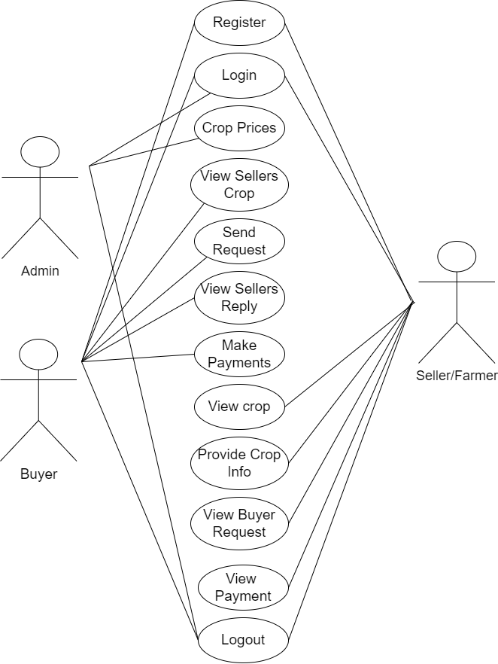

**4.2.2 Class Diagram:**

In software engineering, a class diagram in the Unified Modelling Language (UML) is a type of static structure diagram that describes the structure of a system by showing the system's classes, their attributes, operations (or methods), and the relationships among the classes. It explains which class contains information.

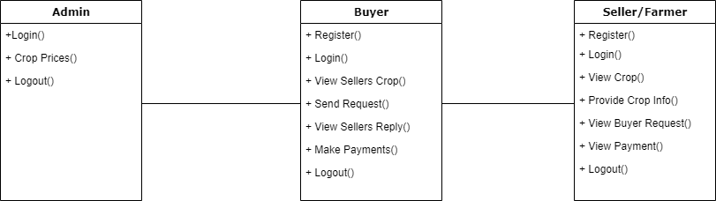

**4.2.3 Sequence Diagram:**

A sequence diagram in Unified Modelling Language (UML) is a kind of interaction diagram that shows how processes operate with one another and in what order. It is a construct of a Message Sequence Chart. Sequence diagrams are sometimes called event diagrams, event scenarios, and timing diagrams.

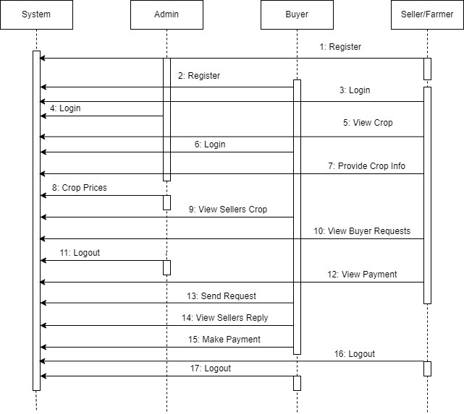

**4.2.4 Collaboration Diagram:**

In collaboration diagram the method call sequence is indicated by some numbering technique as shown below. The number indicates how the methods are called one after another. We have taken the same order management system to describe the collaboration diagram. The method calls are similar to that of a sequence diagram. But the difference is that the sequence diagram does not describe the object organization whereas the collaboration diagram shows the object organization.

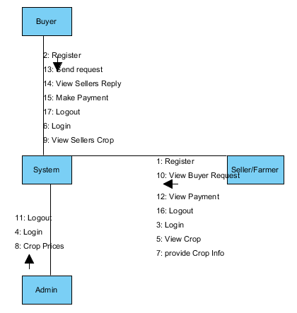

**4.2.5 Deployment Diagram**

Deployment diagram represents the deployment view of a system. It is related to the component diagram. Because the components are deployed using the deployment diagrams. A deployment diagram consists of nodes. Nodes are nothing but physical hardware’s used to deploy the application.

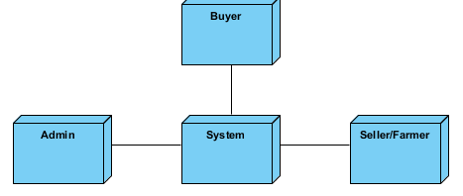

**4.2.6 Activity Diagram:**

Activity diagrams are graphical representations of workflows of stepwise activities and actions with support for choice, iteration and concurrency. In the Unified Modelling Language, activity diagrams can be used to describe the business and operational step-by-step workflows of components in a system. An activity diagram shows the overall flow of control.

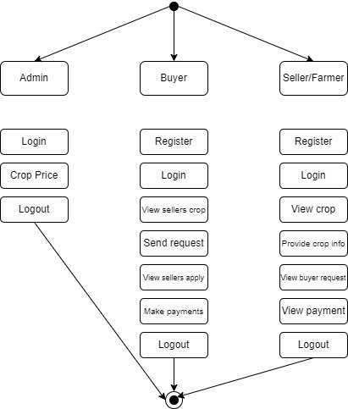

**4.2.7 Component Diagram**:

A component diagram, also known as a UML component diagram, describes the organization and wiring of the physical **c**omponents in a system. Component diagrams are often drawn to help model implementation details and double-check that every aspect of the system's required functions is covered by planned development.

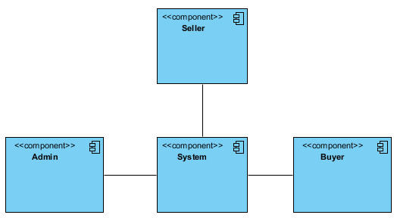

**4.2.8 ER Diagram:**

An Entity–relationship model (ER model) describes the structure of a database with the help of a diagram, which is known as Entity Relationship Diagram (ER Diagram). An ER model is a design or blueprint of a database that can later be implemented as a database. The main components of E-R model are: entity set and relationship set.

An ER diagram shows the relationship among entity sets. An entity set is a group of similar entities and these entities can have attributes. In terms of DBMS, an entity is a table or attribute of a table in database, so by showing relationship among tables and their attributes, ER diagram shows the complete logical structure of a database. Let’s have a look at a simple ER diagram to understand this concept.

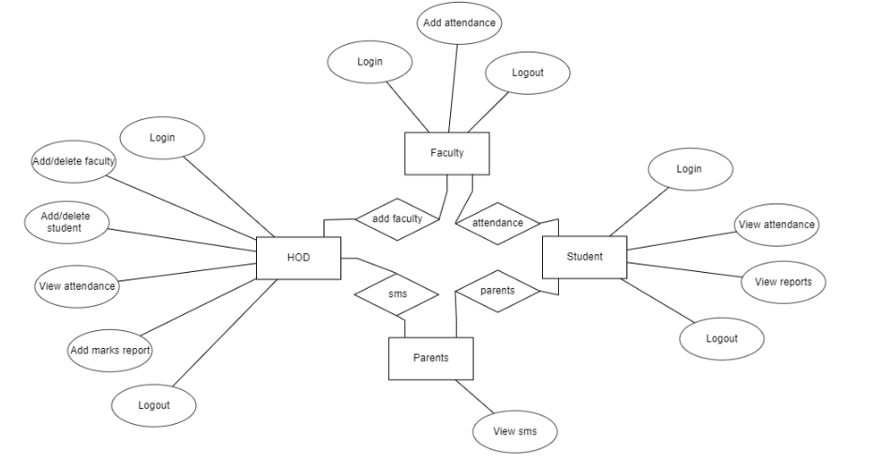

**4.3 DFD Diagram:**

A Data Flow Diagram (DFD) is a traditional way to visualize the information flows within a system. A neat and clear DFD can depict a good amount of the system requirements graphically. It can be manual, automated, or a combination of both. It shows how information enters and leaves the system, what changes the information and where information is stored. The purpose of a DFD is to show the scope and boundaries of a system as a whole. It may be used as a communications tool between a systems analyst and any person who plays a part in the system that acts as the starting point for redesigning a system.

* **Level 1 Diagram:**

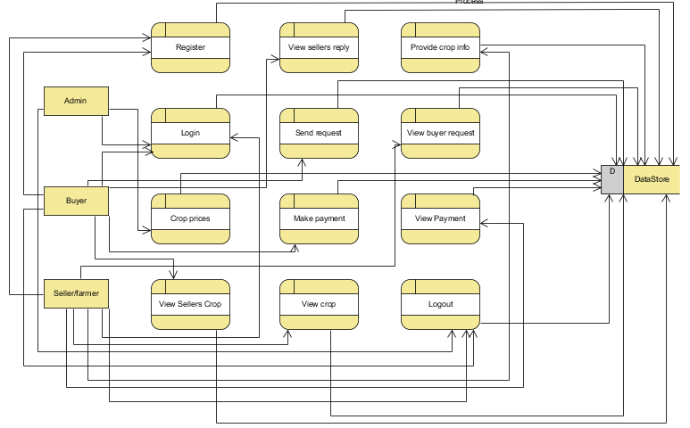

* **Level 2 Diagram:**

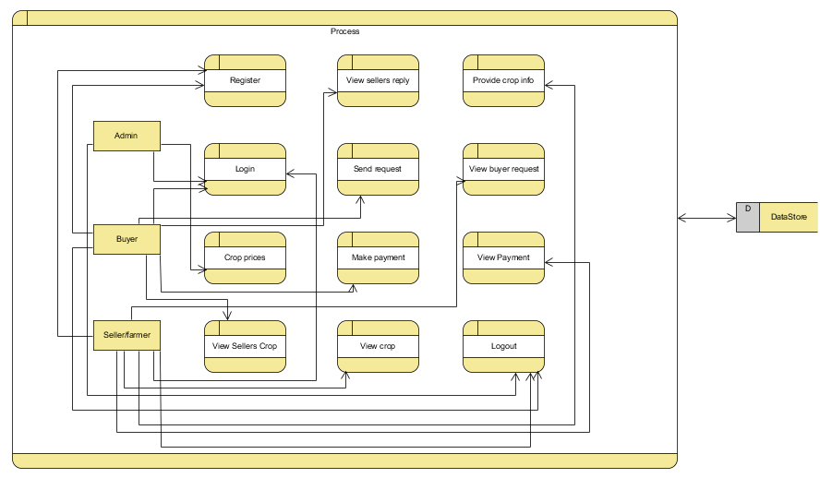

**4.4 System Architecture**

Architecture diagrams can help system designers and developers visualize the high-level, overall structure of their system or application for the purpose of ensuring the system meets their users' needs. They can also be used to describe patterns that are used throughout the design. It's somewhat like a blueprint that can be used as a guide for the convenience of discussing, improving, and following among a team.

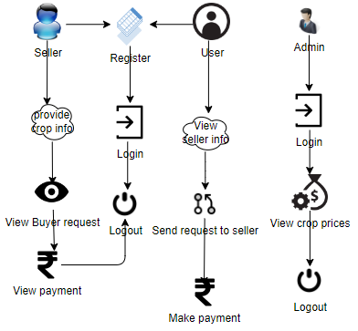

**4.5 Flowchart**

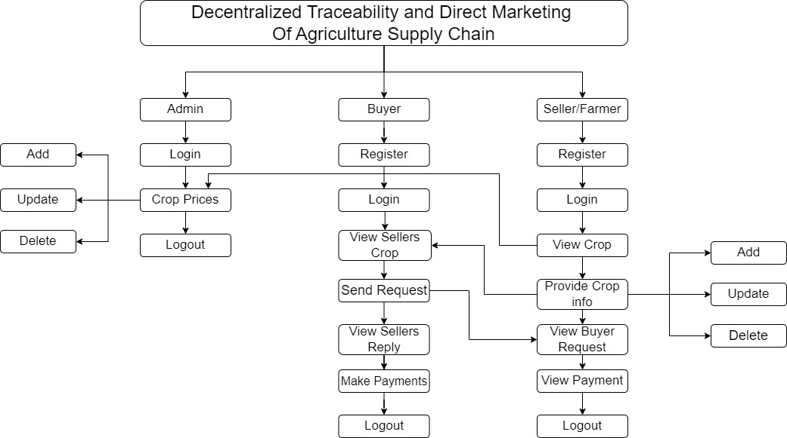

**CHAPTER – 5**

**MODULES / IMPLEMENTATION**

To develop a decentralized traceability for agriculture supply chains, you can break down the functionality into several modules for the different user roles: Buyer, Seller, and Admin. Here are the modules for each role:

**Buyer:**

**Register:** The buyer will register with their details like name, email, password, address, contact, so after that the buyer will login.

**Login:** After registration the buyer will login with their details.

**View Seller's Crop Information:** Once the sellers will add the details the buyer can view those details here.

**Send Request to Seller:** If the buyer wants the details of crop then buyer will send request to seller.

**View Seller Requests:** Displays responses from sellers to the buyer's requests.

**Make Payment:** Once the seller accept the request for the crop the buyer has to pay the amount for that crop.

**Logout:** Allows buyers to logout securely.

**Seller:**

**Register:** The seller will register with their details like name, email, password, address, contact, so after that the seller will login.

**Login:** After registration the seller will login with their details.

**Provide Crop Information:** The seller will add there crop details like (crop name, crop category, and quantity and quality).

**View Buyer Requests:** When the buyer will send the request for the crop, here the buyer will view and he/she has to accept the request.

**View Payments:** Once the buyer will pay the amount for the crops. The seller can view the details of the payment.

**Logout:** Allows sellers to logout securely.

**Admin:**

**Login:** The admin will login with default email and password.

**Crop price:** The admin is the person he/ she will add the crop price for each and every crop details with that crop name, category, maximum cost, minimum cost and quantity.

**Logout:** Allows the admin to log out securely.

**CHAPTER – 6**

**SYSTEM STUDY AND TESTING**

**6.1 Feasibility Study**

The feasibility of the project is analysed in this phase and business proposal is put forth with a very general plan for the project and some cost estimates. During system analysis the feasibility study of the proposed system is to be carried out. This is to ensure that the proposed system is not a burden to the company. For feasibility analysis, some understanding of the major requirements for the system is essential.

Three key considerations involved in the feasibility analysis are

* Economical feasibility
* Technical feasibility
* Social feasibility

**Economical Feasibility**

This study is carried out to check the economic impact that the system will have on the organization. The amount of fund that the company can pour into the research and development of the system is limited. The expenditures must be justified. Thus the developed system as well within the budget and this was achieved because most of the technologies used are freely available. Only the customized products had to be purchased.

### **Technical Feasibility**

This study is carried out to check the technical feasibility, that is, the technical requirements of the system. Any system developed must not have a high demand on the available technical resources. This will lead to high demands on the available technical resources. This will lead to high demands being placed on the client. The developed system must have a modest requirement, as only minimal or null changes are required for implementing this system.

**Social Feasibility**

The aspect of study is to check the level of acceptance of the system by the user. This includes the process of training the user to use the system efficiently. The user must not feel threatened by the system, instead must accept it as a necessity. The level of acceptance by the users solely depends on the methods that are employed to educate the user about the system and to make him familiar with it. His level of confidence must be raised so that he is also able to make some constructive criticism, which is welcomed, as he is the final user of the system.

**System Testing**

The purpose of testing is to discover errors. Testing is the process of trying to discover every conceivable fault or weakness in a work product. It provides a way to check the functionality of components, sub-assemblies, assemblies and/or a finished product It is the process of exercising software with the intent of ensuring that the

Software system meets its requirements and user expectations and does not fail in an unacceptable manner. There are various types of test. Each test type addresses a specific testing requirement.

**6.2 Types of Tests**

**6.2.1 Unit testing**

Unit testing involves the design of test cases that validate that the internal program logic is functioning properly, and that program inputs produce valid outputs. All decision branches and internal code flow should be validated. It is the testing of individual software units of the application .it is done after the completion of an individual unit before integration. This is a structural testing, that relies on knowledge of its construction and is invasive. Unit tests perform basic tests at component level and test a specific business process, application, and/or system configuration. Unit tests ensure that each unique path of a business process performs accurately to the documented specifications and contains clearly defined inputs and expected results.

**6.2.2 Integration testing**

Integration tests are designed to test integrated software components to determine if they actually run as one program. Testing is event driven and is more concerned with the basic outcome of screens or fields. Integration tests demonstrate that although the components were individually satisfaction, as shown by successfully unit testing, the combination of components is correct and consistent. Integration testing is specifically aimed at exposing the problems that arise from the combination of components.

Software integration testing is the incremental integration testing of two or more integrated software components on a single platform to produce failures caused by interface defects.

The task of the integration test is to check that components or software applications, e.g. components in a software system or – one step up – software applications at the company level – interact without error.

**Test Results:**

All the test cases mentioned above passed successfully. No defects encountered.

**Acceptance Testing**

User Acceptance Testing is a critical phase of any project and requires significant participation by the end user. It also ensures that the system meets the functional requirements.

**Test Results:**

All the test cases mentioned above passed successfully. No defects encountered.

**6.2.3 Functional testing**

Functional tests provide systematic demonstrations that functions tested are available as specified by the business and technical requirements, system documentation, and user manuals.

Functional testing is centered on the following items:

Valid Input : identified classes of valid input must be accepted.

Invalid Input : identified classes of invalid input must be rejected.

Functions : identified functions must be exercised.

Output : identified classes of application outputs must be exercised.

Systems/Procedures: interfacing systems or procedures must be invoked.

Organization and preparation of functional tests is focused on requirements, key functions, or special test cases. In addition, systematic coverage pertaining to identify Business process flows; data fields, predefined processes, and successive processes must be considered for testing. Before functional testing is complete, additional tests are identified and the effective value of current tests is determined.

**6.2.4 White Box Testing**

White Box Testing is a testing in which in which the software tester has knowledge of the inner workings, structure and language of the software, or at least its purpose. It is purpose. It is used to test areas that cannot be reached from a black box level.

**6.2.5 Black Box Testing**

Black Box Testing is testing the software without any knowledge of the inner workings, structure or language of the module being tested. Black box tests, as most other kinds of tests, must be written from a definitive source document, such as specification or requirements document, such as specification or requirements document. It is a testing in which the software under test is treated, as a black box .you cannot “see” into it. The test provides inputs and responds to outputs without considering how the software works.

**Test objectives**

* All field entries must work properly.
* Pages must be activated from the identified link.
* The entry screen, messages and responses must not be delayed.

**Features to be tested**

* Verify that the entries are of the correct format
* No duplicate entries should be allowed
* All links should take the user to the correct page.

**TEST CASES:**

|  |  |  |
| --- | --- | --- |
| **Input** | **Output** | **Result** |
| Input image | Decentralized traceability and direct marketing of agriculture supply chains | Success |

* **Test cases Model building:**

|  |  |  |  |  |  |
| --- | --- | --- | --- | --- | --- |
| **S.NO** | **Test cases** | **I/O** | **Expected O/T** | **Actual O/T** | **P/F** |
| 1 | Register  Sellers | Enter name, email, contact, address. | Data added successfully | Added successfully | P |
| 2 | Login Sellers | Enter email and password | Login successfully | Login success | P |
| 3 | Login Sellers | Enter email and password | Password not matched | Login fail | F |
| 4 | Add crop info | Enter crop name, category, quantity | Data added successfully | Added successfully | P |
| 5 | Login admin | Enter email and password | Login successful | Login success | p |
| 6 | Login admin | Enter email and password | Login successful | Login failed | F |

**CHAPTER – 7**

**RESULTS**

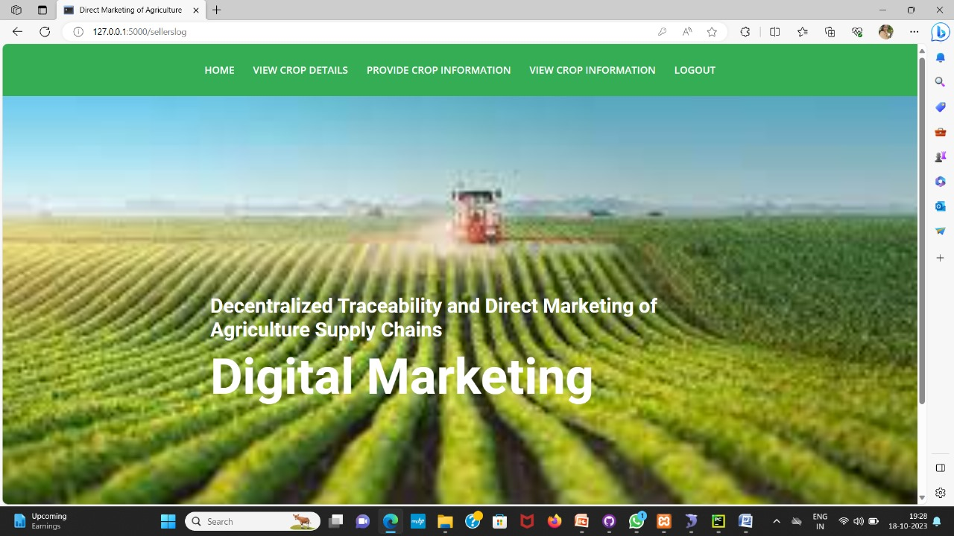

**Fig:** Home Page

**CONCLUSION**

The convergence of decentralized traceability and direct marketing is a transformative force in agriculture supply chains. It promotes transparency and trust while empowering farmers through direct consumer connections, reducing reliance on middlemen and increasing profitability. For consumers, this means heightened confidence in food safety and quality through traceability. Additionally, the streamlined supply chains contribute to environmental sustainability by minimizing food miles. This holistic approach aligns economic interests with environmental responsibility, making it a pivotal advancement in agriculture that benefits all stakeholders.

**REFERENCES**

[1] M. M. Aung and Y. S. Chang, ‘‘Traceability in a food supply chain: Safety and quality perspectives,’’ Food Control, vol. 39, pp. 172–184, May 2014.

[2] T. Bosona and G. Gebresenbet, ‘‘Food traceability as an integral part of logistics management in food and agricultural supply chain,’’ Food Control, vol. 33, no. 2, pp. 32–48, 2013.

[3] J. Hobbs, ‘‘Liability and traceability in agri-food supply chains,’’ in Quantifying the Agri-Food Supply Chain. Springer, 2006, pp. 87–102.

[4] D. Mao, Z. Hao, F. Wang, and H. Li, ‘‘Novel automatic food trading system using consortium blockchain,’’ Arabian J. Sci. Eng., vol. 44, no. 4, pp. 3439–3455, Apr. 2018.

[5] L. U. Opara and F. Mazaud, ‘‘Food traceability from field to plate,’’ Outlook Agricult., vol. 30, no. 2, pp. 239–247, 2001.

[6] F. Dabbene and P. Gay, ‘‘Food traceability systems: Performance evaluation and optimization,’’ Comput. Electron. Agricult., vol. 75, no. 2, pp. 139–146, 2011.

[7] J. Storoy, M. Thakur, and P. Olsen, ‘‘The TraceFood framework— Principles and guidelines for implementing traceability in food value chain,’’ J. Food Eng., vol. 115, no. 2, pp. 41–48, 2013.

[8] M. A. Khan and K. Salah, ‘‘IoT security: Review, blockchain solutions, and open challenges,’’ Future Gener. Comput. Syst., vol. 82, pp. 395–411, May 2018.

[9] L. Lucas. Financial Times. (2018). From Farm to Plate, Blockchain Dishes Up Simple Food Tracking. Accessed: Jun. 12, 2018. [Online]. Available: <https://www.ft.com/content/225d32bc-4dfa-11e8-97e4-13afc22d86d4>

[10] A. Bogner, M. Chanson, and A. Meeuw, ‘‘A decentralised sharing app running a smart contract on the Ethereum blockchain,’’ in Proc. 6th Int. Conf. Internet Things, 2016, pp. 177–178.

[11] K. Salah, M. Rehman, N. Nizamuddin, and A. Al-Fuqaha, ‘‘Blockchain for AI: Review and open research challenges,’’ IEEE Access, vol. 7, pp. 10127–10149, 2019.

[12] H. Hasan and K. Salah, ‘‘Combating deepfake videos using blockchain and smart contracts,’’ IEEE Access, vol. 7, no. 1, pp. 41596–41606, Dec. 2019.

[13] R. Beck, J. S. Czepluch, N. Lollike, and S. Malone, ‘‘Blockchain-the gateway to trust-free cryptographic transactions,’’ in Proc. ECIS, May 2016, p. 153.

[14] M. E. Peck, ‘‘Blockchains: How they work and why they’ll change the world,’’ IEEE Spectr., vol. 54, no. 2, pp. 26–35, Sep. 2017.

[15] K. Toyoda, P. T. Mathiopoulos, I. Sasase, and T. Ohtsuki, ‘‘A novel blockchain-based product ownership management system (POMS) for anti-counterfeits in the post supply chain,’’ IEEE Access, vol. 5, pp. 17465–17477, 2017